CCMath 8 EOG Prep MORE GEOMETRY NDC __________________________________________________

1a) REFLECTION 1b) Explain HOW to do this problem
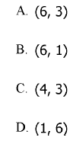
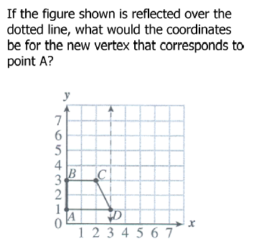
2a) DILATION  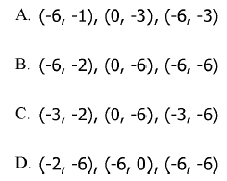  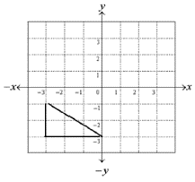  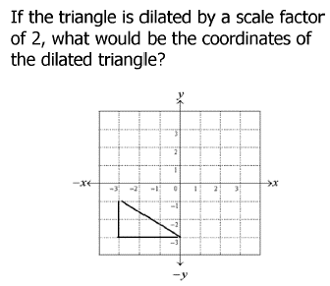  Explain HOW to do this problem | 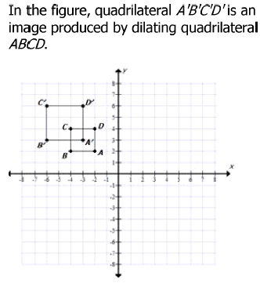  2b)  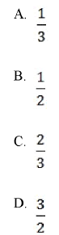  What is the scale factor of the dilation?
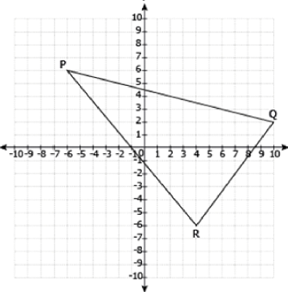
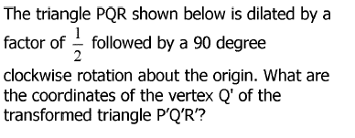
3) ROTATION

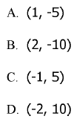

Explain HOW to do this problem

4a) TRANSVERSALS & PARALLEL LINES 4b) Can you identify all pairs of angle relationships?
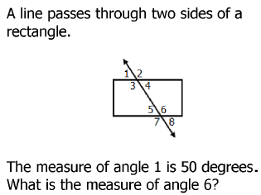
8
7
6
3
4
2
5
1
Vertical Corresponding

Alt. Interior Alt. Exterior
- 50 degrees C. 80 degrees
B. 130 degrees D. 150 degrees

5) VERTICAL ANLGES  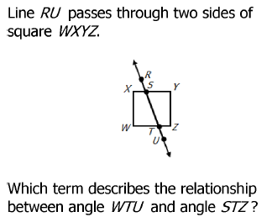  - Alternate interior C. alternate exterior  - corresponding D. vertical | 6) THE PYTHAGOREAN THEOREM  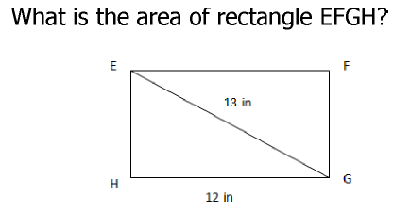  - 5 in² B. 30 in² C. 50 in² D. 60 in²
7) VOLUME (working backwards)  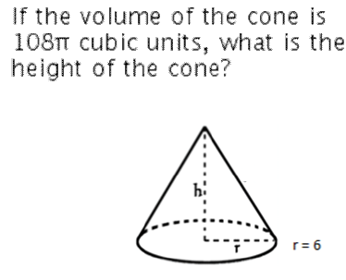  A. 6 units B. 7 units C. 8 units D. 9 units | 8) VOLUME  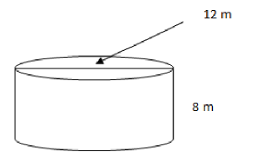  What is the volume of the cylinder?
9a) VOLUME
9b) What is the volume formula for a sphere? What can you do to remember it?
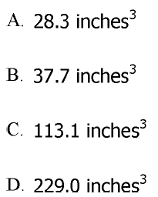
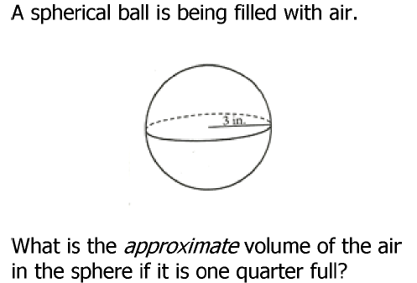

10a) ANGLES

Find the values of x & y in the triangle. 10b) EXTERIOR ANGLE RULE
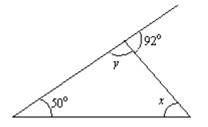
The sum of the 2 opposite interior angles equals
the exterior angle.

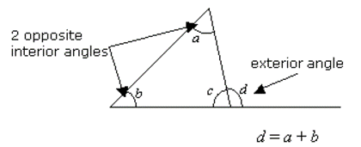

10c) TRIANGLE SUM RULE
10d) EXAMPLE 10e) EXAMPLE
All 3 angles inside of any triangle = 180 degrees.

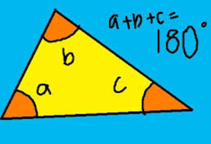

Transformations Review Videos:

Dilations Rotations Reflections Translations Combination

